**NAME: Ayush Agrawal**

**DATE: 24-02-2022**

***HTML ASSIGNMENTS***

**Write the HTML for the following screen.**

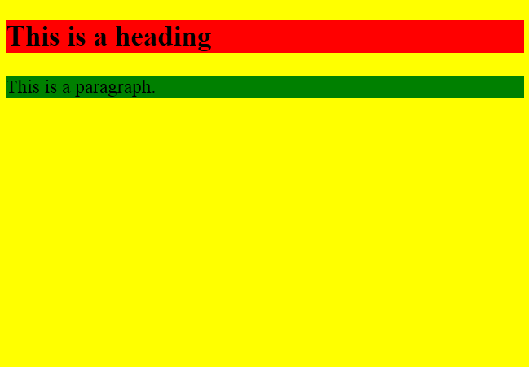

**My View Page:**

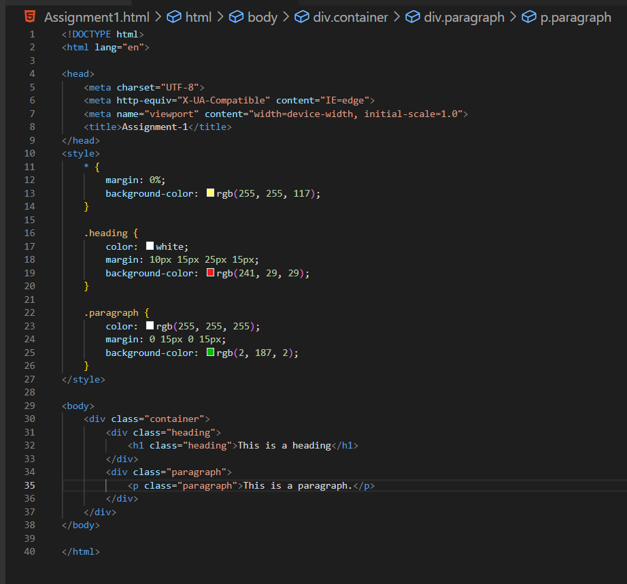

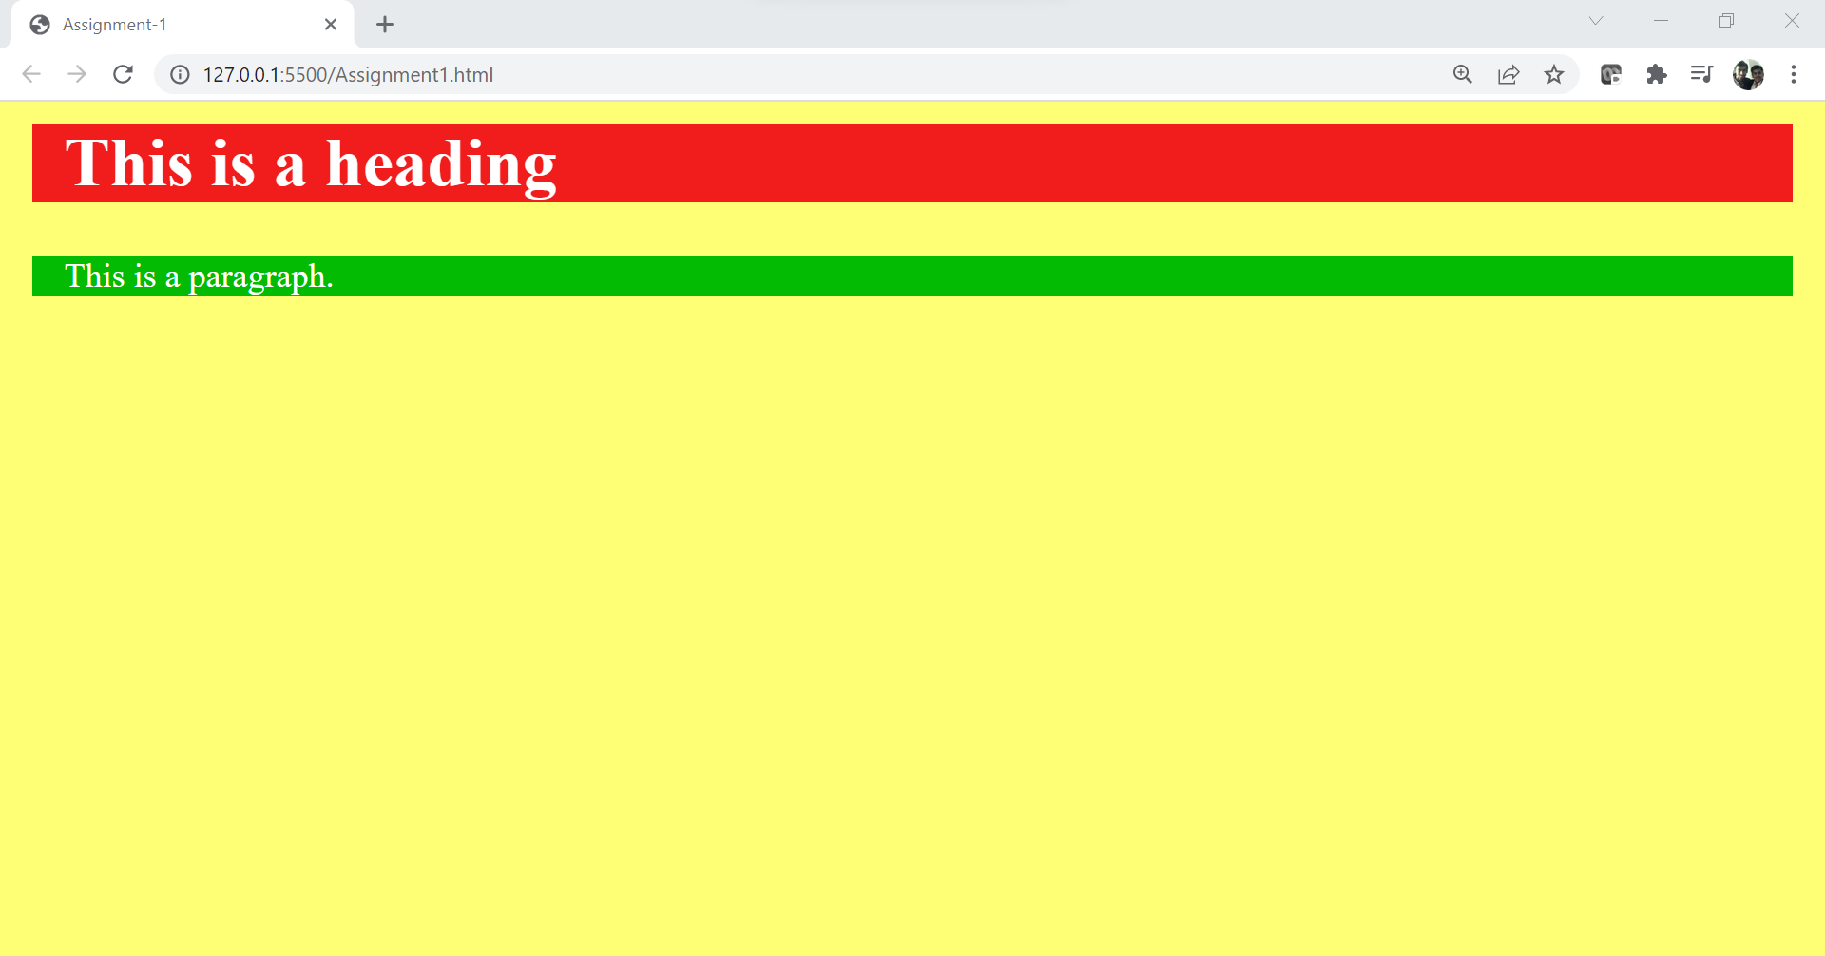

Write HTML for the following text and images below? The first image has a square border and the second image has no border.

**HTML Code:**

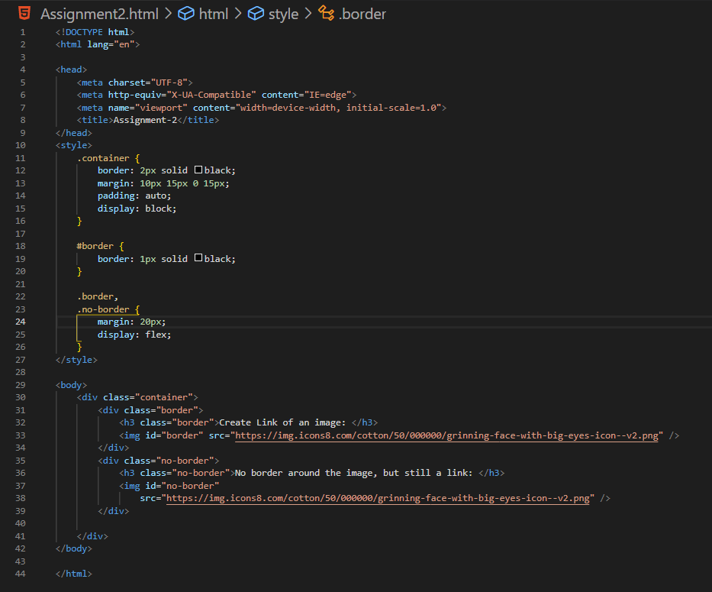

**My View Page:**

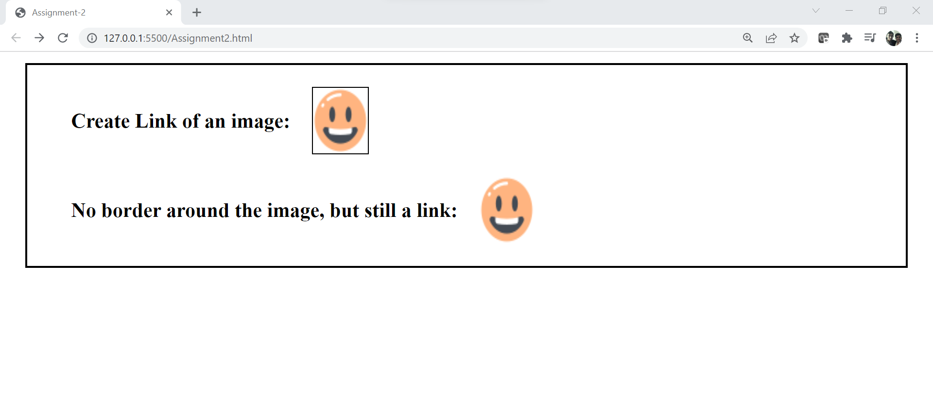

3) Write the HTML for the following text. Do not consider the outermost border:

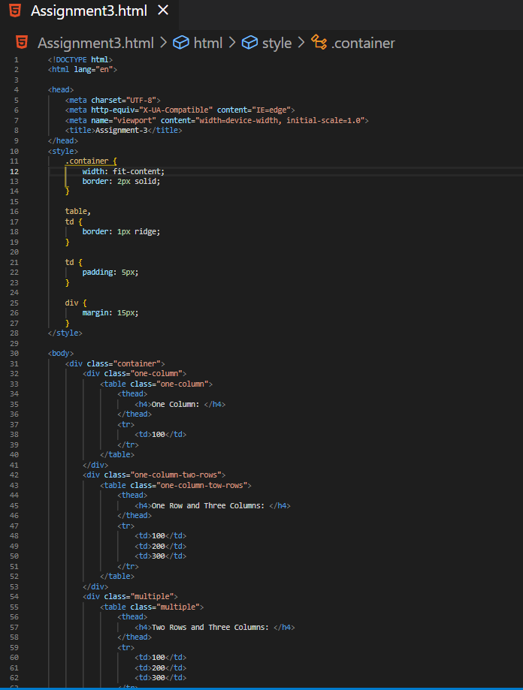

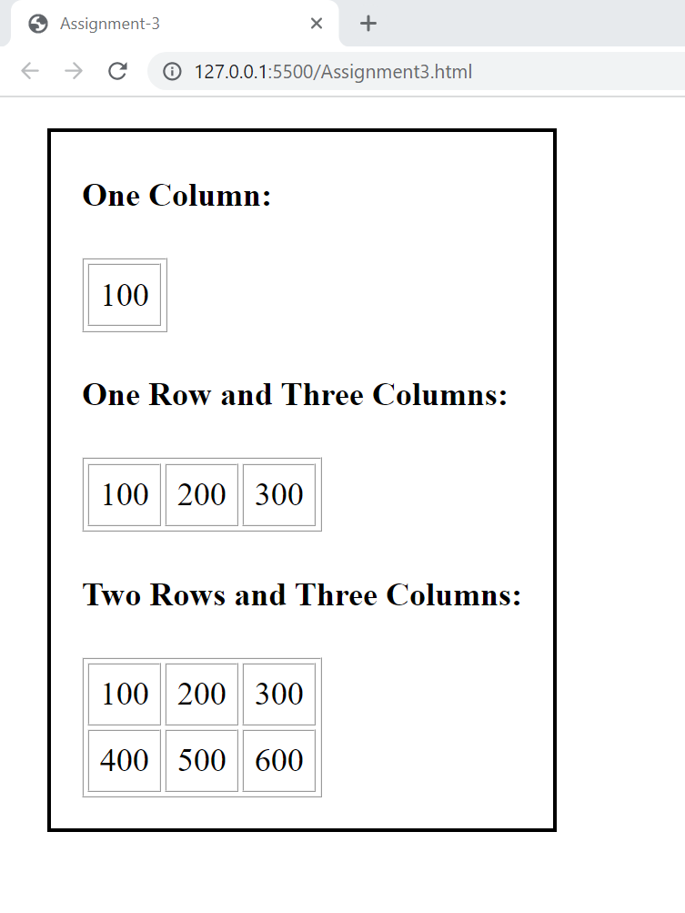

4. Write the HTML for the following text. Do **not** consider the outermost border :

|  |  |  |  |  |  |  |  |  |  |  |  |  |
| --- | --- | --- | --- | --- | --- | --- | --- | --- | --- | --- | --- | --- |
| **This table has borders:**   |  |  |  | | --- | --- | --- | | 100 | 200 | 300 | | 400 | 500 | 600 |   **And this table has no borders:**   |  |  |  | | --- | --- | --- | | 100 | 200 | 300 | | 400 | 500 | 600 | |

My View Page:

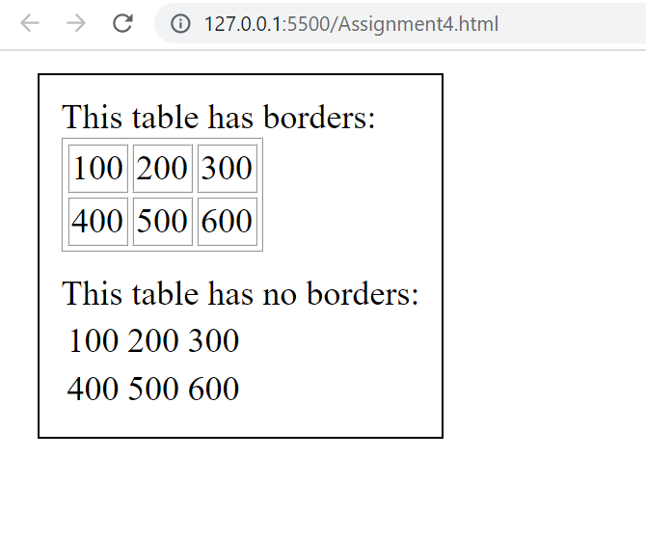

5) Write the HTML for the following text. Do not consider the outermost border :

**HTML Code:**

<!DOCTYPE html>

<html lang="en">

<head>

    <meta charset="UTF-8">

    <meta http-equiv="X-UA-Compatible" content="IE=edge">

    <meta name="viewport" content="width=device-width, initial-scale=1.0">

    <title>Assignment-5</title>

</head>

<style>

    * {

        margin: 0%;

    }

    .container {

        margin: 5px 25px;

        border: 1px solid;

        width: fit-content;

        padding: 10px 20px 10px 20px;

    }

    .list {

        margin: 8px;

    }

</style>

<body>

    <div class="container">

        <div class="numbered">

            <h3>Numbered List:</h3>

            <div class="list">

                <ol type="1">

                    <li>Apples</li>

                    <li>Bananas</li>

                    <li>Lemons</li>

                    <li>Oranges</li>

                </ol>

            </div>

        </div>

        <div class="letters">

            <h3>Letters List:</h3>

            <div class="list">

                <ol type="A">

                    <li>Apples</li>

                    <li>Bananas</li>

                    <li>Lemons</li>

                    <li>Oranges</li>

                </ol>

            </div>

        </div>

        <div class="lowercase-letters">

            <h3>Lowercase Letters List:</h3>

            <div class="list">

                <ol type="a">

                    <li>Apples</li>

                    <li>Bananas</li>

                    <li>Lemons</li>

                    <li>Oranges</li>

                </ol>

            </div>

        </div>

        <div class="roman-numbers">

            <h3>Roman Numbers List:</h3>

            <div class="list">

                <ol type="I">

                    <li>Apples</li>

                    <li>Bananas</li>

                    <li>Lemons</li>

                    <li>Oranges</li>

                </ol>

            </div>

        </div>

        <div class="lowercase-roman">

            <h3>Numbered List:</h3>

            <div class="list">

                <ol type="i">

                    <li>Apples</li>

                    <li>Bananas</li>

                    <li>Lemons</li>

                    <li>Oranges</li>

                </ol>

            </div>

        </div>

    </div>

</body>

</html>

**My View Page:**

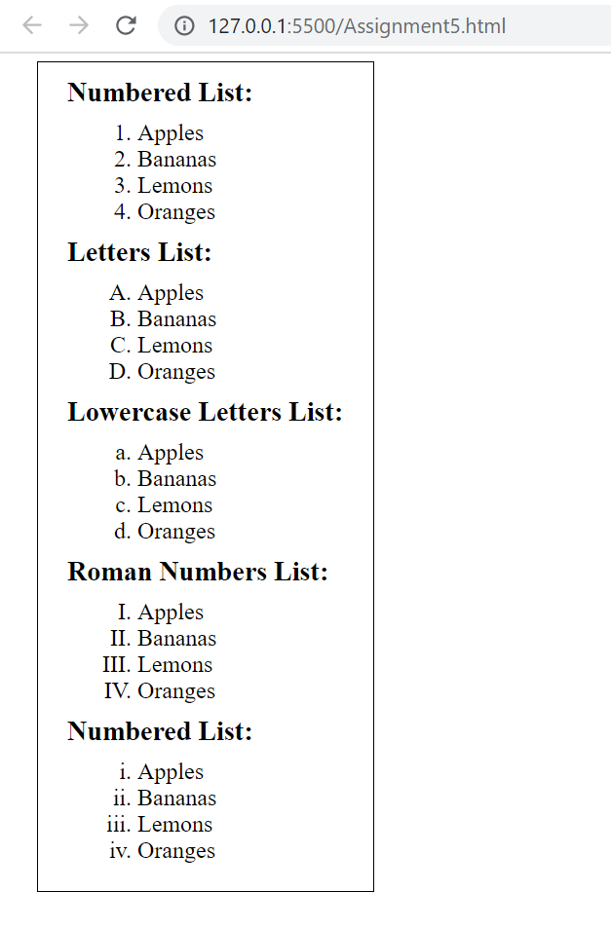

6) Write the HTML for the following image shown below. Note: The characters in a password field are masked (shown as asterisks or circles). Do not consider the outermost border:

**HTML Code:**

<!DOCTYPE html>

<html lang="en">

<head>

    <meta charset="UTF-8">

    <meta http-equiv="X-UA-Compatible" content="IE=edge">

    <meta name="viewport" content="width=device-width, initial-scale=1.0">

    <title>Assignment-6</title>

</head>

<style>

    * {

        margin: 0%;

    }

    .container {

        margin: 20px 30px;

        border: 2px solid;

        width: fit-content;

        padding: 20px;

    }

    .input-box {

        padding: 10px;

        justify-content: space-evenly;

    }

    input {

        padding: 5px;

    }

</style>

<body>

    <div class="container">

        <div class="form">

            <form>

                <div class="input-box">

                    <label for="username">Username : </label>

                    <input type="text">

                </div>

                <div class="input-box">

                    <label for="username">Password : </label>

                    <input type="password">

                </div>

            </form>

        </div>

    </div>

</body>

</html>

**MyViewPage:**

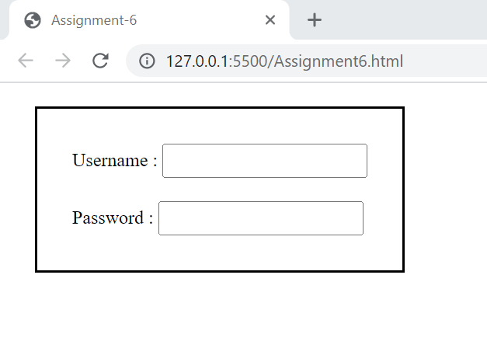

7)Write the HTML for the following image shown below. Do not consider the outermost border :

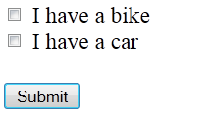

**HTML Code:**

<!DOCTYPE html>

<html lang="en">

<head>

    <meta charset="UTF-8">

    <meta http-equiv="X-UA-Compatible" content="IE=edge">

    <meta name="viewport" content="width=device-width, initial-scale=1.0">

    <title>Assignment-7</title>

</head>

<style>

    * {

        margin: 0%;

    }

    .container {

        margin: 30px 50px;

        border: 1px solid;

        width: fit-content;

        padding: 20px;

    }

    .input-group {

        margin: 10px;

    }

    .button {

        margin: 25px 10px;

    }

</style>

<body>

    <div class="container">

        <div class="form">

            <form>

                <div class="input-group">

                    <input type="checkbox" id="vehicle1" value="Bike">

                    <label for="vehicle1">I have a bike</label>

                </div>

                <div class="input-group">

                    <input type="checkbox" id="vehicle2" value="Car">

                    <label for="vehicle2">I have a car</label>

                </div>

                <div class="button">

                    <button type="submit">

                        Submit

                    </button>

                </div>

            </form>

        </div>

    </div>

</body>

</html>

**MyView Page:**

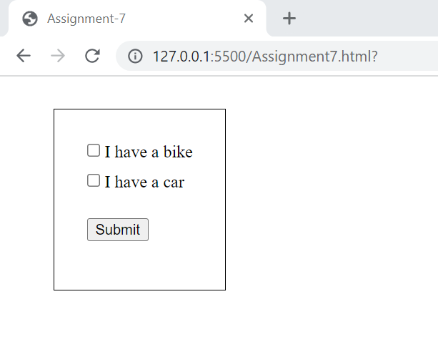

8) Write the HTML for the following image shown below. Do not consider the outermost border :

**HTML Code:**

<!DOCTYPE html>

<html lang="en">

<head>

    <meta charset="UTF-8">

    <meta http-equiv="X-UA-Compatible" content="IE=edge">

    <meta name="viewport" content="width=device-width, initial-scale=1.0">

    <title>Assignment-8</title>

</head>

<style>

    * {

        margin: 0%;

    }

    .container {

        border: 1px solid;

        width: fit-content;

        padding: 20px;

    }

    table,

    td,

    th {

        border: 1px solid;

        border-collapse: collapse;

        padding: 30px;

    }

    th {

        text-align: left;

    }

</style>

<body>

    <div class="container">

        <div class="table">

            <table>

                <tr style="background-color: rgb(159, 255, 159);">

                    <th colspan="2">top</th>

                </tr>

                <tr>

                    <td rowspan="2">left</td>

                    <td rowspan="2">right</td>

                </tr>

            </table>

        </div>

    </div>

</body>

</html>

**MyView Page:**

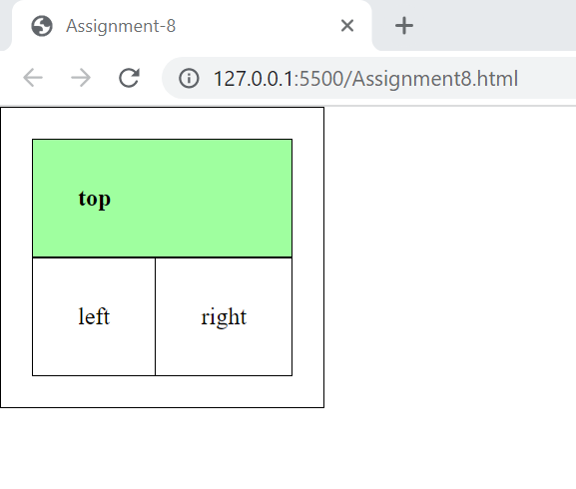

**9) Write the HTML for the following image shown below. Do not consider the outermost border :**

|  |  |  |  |  |
| --- | --- | --- | --- | --- |
| |  |  | | --- | --- | | topleft | topright | | botleft | botright | |

**HTML Code:**

<!DOCTYPE html>

<html lang="en">

<head>

    <meta charset="UTF-8">

    <meta http-equiv="X-UA-Compatible" content="IE=edge">

    <meta name="viewport" content="width=device-width, initial-scale=1.0">

    <title>Assignment-9</title>

</head>

<style>

    * {

        margin: 0%;

    }

    .container {

        border: 1px solid;

        width: fit-content;

        padding: 20px;

    }

    table,

    td,

    th {

        border: 1px solid;

        border-collapse: collapse;

    }

    td {

        padding-top: 30px;

        text-align: end;

    }

</style>

<body>

    <div class="container">

        <div class="table">

            <table>

                <tr style="background-color: rgb(159, 255, 159);">

                    <th>topleft</th>

                    <th>topright</th>

                </tr>

                <tr>

                    <td rowspan="2">bottomleft</td>

                    <td rowspan="2">bottomright</td>

                </tr>

            </table>

        </div>

    </div>

</body>

</html>

**My View Page:**

